Galaxies and
The Hubble Deep Field

❍ Composition of the Galaxies
- Billion of Stars.
- (Likely many Planets.)
- Lots of Gas, Molecules.
- Lots of Dust.
- Dark Matter.

❍ Types of Galaxies
- spiral
- elliptical
- irregular
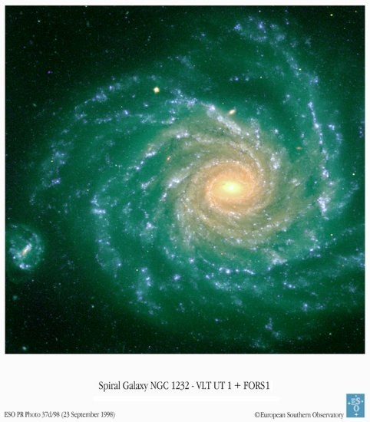

❍ Activities

Activity 1
Counting the Galaxies in the Hubble Deep Field.

Activity 2
Classifying and Identifing the galaxies in the Hubble Deep Field.

Counting the Galaxies
in the Hubble Deep Field

1. Which Camera Are You Using?
❑ Camera A
❑ Camera B
❑ Camera C

2. Which Cell Are You Using?
❑ a  1
❑ b  2
❑ c  3
❑ 4

3. How Many Galaxies is there in this Cell?
➔

4. How Many Galaxies Did Your Buddy Find?
➔

5. Finding How Many Galaxies There Might Be in the Universe
Multiply your number of Galaxies found by 3.5x10⁸ to obtain an estimation of the number of galaxies in the Universe:

x 3.5 x 10⁸ =

Your Hubble Deep Number of Galaxies
Field Cell Number in the Universe
of objects

(This multiplication gives in fact a lower limit of the Number of Galaxies in the Universe, and assumes that galaxies are distributed uniformly in the sky.)

Adaptation from STScI’s Amazing Space: http://amazing-space.stsci.edu/resources/explorations/hdf
Classifying and Identifying
Galaxies
in the Hubble Deep Field

1. Which Camera Are You Using?
❑ Camera A
❑ Camera B
❑ Camera C

2. Classify and Identify the Objects in the Image

Irregular
Blue
White
Yellow
Red

3. Compare Your Results with Your Buddy

Adaptation from STScI’s Amazing Space: http://amazing-space.stsci.edu/resources/explorations/hdf
Astronomers’ Chart
Camera A

 |  |  |  |  | Irregular
Blue | - | - | - | 10 | 2, 6
White | 1 | 4 | 5, 8 | 3, 14 | 9
Yellow | 15 | 12 | 7,13 | - | -
Red | - | - | - | - | 11

Adaptation from STScI’s Amazing Space: http://amazing-space.stsci.edu/resources/explorations/hdf

Astronomers’ Chart
Camera B

 |  |  |  |  | Irregular
Blue | - | - | - | 28, 29 | 18, 23
White | 17, 26 | - | 19, 25 | 21 | -
Yellow | - | - | - | 22, 24, 37 | -
Red | - | 16 | 20, 30 | - | -

Adaptation from STScI’s Amazing Space: http://amazing-space.stsci.edu/resources/explorations/hdf

Astronomers’ Chart
Camera C

 |  |  |  |  | Irregular
Blue | 35 | - | - | - | 32, 43
White | - | 36 | 34 | - | 33, 38, 40
Yellow | - | 41 | - | 31 | -
Red | - | 44, 45 | 37 | 39, 42 | -

Adaptation from STScI’s Amazing Space: http://amazing-space.stsci.edu/resources/explorations/hdf

