EINSTEIN, PERRIN, AND AVOGADRO’S NUMBER – 1905 REVISITED*

Ronald Newburgh¹, Joseph Peidle², and Wolfgang Rueckner²

¹ Harvard University Extension School, Cambridge , MA 02138
² Science Center, Harvard University, Cambridge, MA 02138
E-mail: rgnew@verizon.net, peidle@fas.harvard.edu, rueckner@fas.harvard.edu

PACS numbers: 01.50P, 01.65, 07.60, 42.80, 51.20

ABSTRACT

We have repeated Perrin’s 1908 experiment for the determination of Avogadro’s number by observing mean square displacements of small particles undergoing Brownian motion. Our apparatus differs from Perrin’s by the use of a modern CCD camera coupled with software and is therefore far less tedious to perform. We review Einstein’s 1905 analysis of Brownian motion, which was the basis of the experiment as well as Langevin’s alternative derivation of the Einstein equation for mean square displacement. Our results give a value of 7 x 10 ²³ ± 20% for Avogadro’s number.

INTRODUCTION

As is well known, Einstein published three great papers in 1905, the annus mirabilis. The paper on relativity ¹ and that on light quanta and the photoelectric effect ² have overshadowed the third ³. In this third paper he examined the possibility that molecular motions could explain Brownian motion. One must remember that in 1905 many scientists, including Mach and Ostwald, did not believe in the existence of atoms. Einstein carried out a statistical analysis of molecular motion and its effect on particles suspended in a liquid. From this analysis he calculated the mean square displacement of these particles. As he says in Ref. 3, “If the movement discussed here can actually be observed (together with the laws relating to it that one would expect to find), then classical thermodynamics can no longer be looked upon as applicable with precision to bodies even of dimensions distinguishable in a microscope; an exact determination of actual atomic dimensions is then possible. On the other hand, had the prediction of this movement proved to be incorrect, a weighty argument would be provided against the molecular-kinetic conception of heat”.

Indeed, it was just these predictions that led to acceptance of the atomic or molecular-kinetic theory. Perrin, a brilliant experimentalist, believed strongly in molecular reality. He carried out a series of experiments ⁴ in the first decade of the twentieth century, one of which depended on Einstein’s calculation of the mean square displacement of suspended particles. His results confirmed Einstein’s equation and thus the molecular-kinetic theory.

In this paper we shall review the Einstein equation for mean square displacement concentrating especially on his assumptions in formulating it. We shall then describe a modern version of Perrin’s displacement experiment. Although the apparatus is essentially the same as Perrin’s, the use of a modern camera coupled to a computer with software makes the measuring process far easier.

THE EINSTEIN EQUATION FOR MEAN SQUARE DISPLACEMENT

In his autobiographical notes ⁵ Einstein describes his goal of proving the existence of atoms. He did accept Maxwell-Boltzmann statistics or, as he referred to it, the molecular-kinetic theory of heat. From this theory he concluded that small but microscopically visible particles suspended in a liquid would exhibit random movements. Moreover, he thought that these movements might well be identical with those of Brownian motion.

His first great insight was the recognition that a suspension of such particles in liquid was analogous to a solution of molecules in a solvent and as such exhibited osmotic pressure. This belief he based on the argument that a suspended particle differs from a dissolved molecule solely by its dimensions. This conjecture he proved by calculating the entropy and free energy of the entire system of particles and liquid. This required integration over all variables of state, i.e. over configuration space. This analysis showed that the molecule-kinetic theory of heat leads directly to osmotic pressure. Physicists tend to neglect osmosis. It generally appears in the physical chemistry curriculum. Yet one must agree with Hinshelwood ⁶ who says, “Osmosis is sometimes dismissed as an obscure and secondary effect. It is, on the contrary, the most direct expression of the molecular and kinetic nature of solutions”.

Given the concept of osmosis, Einstein then looked on the problem of movements of the particles as a case of diffusion combined with a dynamic equilibrium. For a complete exegesis of his thought one should consult the collection ⁷ of all his papers on Brownian motion published between 1905 and 1911. If we take c as the concentration, we can write the diffusion equation as

∂c/∂t = D∇²c, (1)

where D is the diffusion constant. The osmotic pressure Π
is given as

ΠV = nRT, (2)

where V is the volume, n the number of moles of the suspended particles, R the gas constant, and T the absolute temperature. Note the similarity of this equation to that for the pressure of an ideal gas. There is a continuum from microscopically visible particles to the point particles of an ideal gas.

Einstein first assumed a resistive force F acting on the individual particles, a force that depended on position but not on time. For simplicity he took this force to act in the x-direction only. This resistive force is the Stokes’ law for the motion of a sphere in a viscous medium. The force due to the osmotic pressure is in the opposite direction, so that dynamic equilibrium is achieved. From this he calculated the diffusion constant to be

D =(RT/N) / (6πηr), (3)

Where N is Avogadro’s number, η the viscosity of the liquid, and r the radius of the particles.

By integrating the diffusion equation over many time intervals τ and then averaging, he found a second expression for D in terms of the mean square displacement <x²>, namely

D = <x²> /2τ. (4)

This represents the average displacement taken over many intervals. Equating the two equations for D gives an expression for Avogadro’s number

N = (1/<x²>) (RT/3πηr)τ. (5)

Einstein mentioned that this equation does not hold for arbitrarily short time intervals.

Three years after Einstein’s first paper Langevin ^{8,9} obtained the same equation for Avogadro’s number by a different and simpler derivation. Einstein found the mean square displacement by averaging over a large number of particles for a single observation time. This was a consequence of his use of osmotic pressure. Langevin applied Newton’s second law to a single particle and averaged the square displacements of this particle for a very large number of observation times, while assuming that the square displacement for each time interval is independent of the preceding value. His derivation is given in the appendix.

PERRIN’S DETERMINATION OF AVOGADRO’S NUMBER

Perrin used several approaches in determining Avogadro’s number, all of which are discussed in Ref. 4. These included direct measurements of the mean square displacement and application of Einstein’s equation. This he did by preparing suspensions of particles of gamboge and of mastic of uniform size. He observed the particles with a camera lucida, a device that projects an image on a plane surface suitable for tracing. He made measurements of the displacements for as many as 200 distinct granules and obtained a value of N equal to 7.15 x 10 ²³.

It is perhaps worth quoting Sommerfeld’s remark ¹⁰ in his contribution to Einstein’s 70th birthday. “The old fighter against atomistics, Wilhelm Ostwald, told me once that he had been converted to atomistics by the complete explanation of Brownian motion.”

EXPERIMENTAL DETAILS

We have essentially replicated Perrin’s experiment, though with a few modern touches. The apparatus, shown schematically in Fig. 1, consists of a microscope objective, the sample of uniform spherical particles dispersed in a saline solution, a camera, and a software program to measure position of particles. The main difference between Perrin’s arrangement and ours is the replacement of the camera lucida with a CCD camera connected to a computer plus a software program to read the displacements. The camera records sequential images of a particle at fixed time intervals. A dimpled glass slide is used to minimize convection currents.

An inexpensive commercial CCD camera with its associated software allows us to record successive positions (x- and y-coordinates) of a single particle at given time intervals. The microscope focus control is adjusted continuously to keep the particle in focus, effectively projecting the three-dimensional motion of the particle onto a plane. Open source software called ImageJ is used to locate the particle in each image and record a table of positions. The mean-square displacement in units of pixels is calculated for both x- and y-coordinates, and averaged. The CCD array is calibrated by imaging a replica diffraction grating with known line spacing.

RESULTS

Figure 2 shows approximately 200 displacements for a single particle. The circular nature of the pattern shows the absence of convection. The near equality of the mean square x- and y-displacements provides further confirmation.

Fig. 3 shows the mean-square displacement for time intervals ranging from 0.5 to 10 seconds, for 0.5, 1.1 and 2.1 micron diameter spheres. The lines are fits to the data, forced through the origin. Avogadro’s number is deduced from the slope. The results are given in Table 1.

Table 1.
Particle diameter (microns) | Slope (10⁻¹³m²/sec) | N_{A} (10²³)
0.50±0.02 | 12.3±0.4 | 8.2±0.4
1.09±0.04 | 7.3±0.2 | 6.4±0.3
2.06±0.02 | 4.3±0.2 | 5.7±0.2

SUMMARY

One might ask why repeating an experiment one hundred years after it was first done has merit. We feel that several reasons justify the effort. As stated at the beginning of this paper, Einstein’s statistics paper has lain in the shadow of the relativity and photon papers of 1905. It is a beautiful piece of scientific exposition, presented in a modest fashion. Einstein does not claim that the results explain Brownian motion or prove the validity of the molecular kinetic theory. Rather he says that the predictions, if observed, will tend to confirm the theory, adding that failure to observe them would weigh strongly against the theory. It is significant that a theoretician as great as Einstein recognized that theory must stand or fall with experiment.

It is also important, we feel, to remind physicists of the importance of the concept of osmotic pressure. Today, unlike in Einstein’s time, it has been abandoned to the chemists. Yet it is not a secondary effect but of prime importance in the molecular kinetic picture of matter. We should remind students of this.

This experiment has an important pedagogic value as well. Statistical concepts are, by their very nature, somewhat abstract unless one actually tosses coins or rolls dice. To grasp the ideas in a physical context is more difficult. We were struck by our own reactions to measuring the successive positions of a particle. Consider one hundred frames taken at 1-second intervals. One picks out a particle and records its position. This is not difficult since the computer program makes the measurement. The next frame is selected and the measurement repeated. The process is repeated for all hundred frames. Each time the particle moves but a short distance. Moreover the direction is random. In this way one has a truly hands-on feeling for the Brownian motion and its statistical nature. The result is that the statistical analysis loses its arcane nature and leads to a fuller conceptual understanding for the student.

We are also all too forgetful of the history of physics. Students often feel that progress in physics is a smooth road without controversy. New theories are not accepted without a fight. Planck once said that old theories die funeral by funeral. The new theory triumphs when all who learnt the old are gone. We should remember that the molecular kinetic theory was accepted only after many bitter fights. As Ostwald said, it was the work of Einstein and Perrin that convinced him of its truth. We hope that this paper will serve as a reminder of our history.

APPENDIX: LANGEVIN’S DERIVATION OF THE EINSTEIN EQUATION

Langevin’s derivation of the Einstein relation is as follows. Each colloidal particle is subject to two forces. One is the molecular bombardment, which we call F and which causes Brownian motion. The other is a resistive force proportional to the velocity v of the particle. This force is δv, where δ is the damping coefficient related to viscosity. Confining ourselves to one dimension, we write the equation of motion of a particle as

m(d²x/dt²) + δ(dx/dt) + F = 0 (A1)

Multiplying Eq. 1 by x and keeping in mind that

x(d²x/dt²) = (1/2)d²(x²)/dt² – (dx/dt)², (A2)

we obtain

(m/2) d²(x²)/dt² – m(dx/dt)² + (δ/2) d(x²)/dt + Fx = 0 . (A3)

If we examine a large number of particles, the average value of Fx is zero, since F will, on the average, have equal numbers of positive and negative values. From the equipartition law the average value of the kinetic energy of a single particle for one degree of freedom is

(m/2)(dx/dt)² = RT/2N (A4)

Let α equal the mean value of d(x²)/dt. We can therefore write Eq. 3 as

(m/2)(dα/dt) – RT/N + δα/2 = 0 (A5)

Integrating, we obtain

α = 2RT/Nδ + A e ^{-tδ /m},
(A6)
where A is an integration constant. If we take the specific gravity of the colloid particles as unity, set δ equal to 6πrη from Stokes’s law, and take r as 1μ and η as the viscosity of water at room temperature, we find that m/δ equals 10⁻⁵ s⁻¹. Hence for any reasonable observation time τ, the term A e ^{-tδ /m} approaches zero. Therefore Eq. 6 becomes

α = 2RT/Nδ (A7)

Integrating over the observation time τ gives our mean squared displacement (for one degree of freedom) as

<x²> =RTτ / 3πNrη (A8)

This is the Einstein equation. A measurement of the mean square displacement combined with the observation time, the absolute temperature, the radius of the particles, and the viscosity allows us to determine Avogadro’s number.

FOOTNOTE

*A shortened version of this paper was presented at the meeting at the University of Paris (Orsay) on 21. October. 2005 for the retirement of Jean-Pierre Delaboudiniere from the Institut d’Astrophysique Spatiale.

REFERENCES

- A. Einstein Ann. d. Phys., 17, p. 891 (1905).

- A. Einstein Ann. d. Phys., 17, p. 132 (1905).

- A. Einstein Ann. d. Phys., 17, p. 549 (1905).

- J. Perrin, Brownian Movement and Molecular Reality, trans. F.Soddy (London: Taylor and Francis, 1910). This is a translation of a paper that appeared in the Annales de Chimie et de Physique, 8me Series, 1909.

- A. Einstein, “Autobiographical Notes” in Paul Schilpp, Albert Einstein, Philosopher-Scientist (Library of Living Philosophers, 1949, Evanston, IL) pp. 47 , 49.

6. C. N. Hinshelwood, The Structure of Physical Chemistry, p.91 (Oxford, 1951).

- A. Einstein, Investigations on the Theory of Brownian Movement, trans. By A. D. Cowper (Dover, 1956).

- P. Langevin, Comptes Rendus, 146, 530 (1908).

- D. Lemons and A. Gythiel, Am. J. Phys. 65, 1079 (1997). This is a translation of the 1908 Langevin paper.

- A. Sommerfeld, in Paul Schilpp, Albert Einstein, Philosopher-Scientist (Library of Living Philosophers, 1949, Evanston, IL) p. 105.

FIGURE CAPTIONS

Figure 1 Apparatus to view Brownian motion. It is essentially the same as Perrin’s except that a modern CCD camera and software replaces his camera lucida.

Figure 2 View of approximately 200 displacements. There is a 1 second time interval between observations.

Figure 3 Mean square displacements as a function of time.
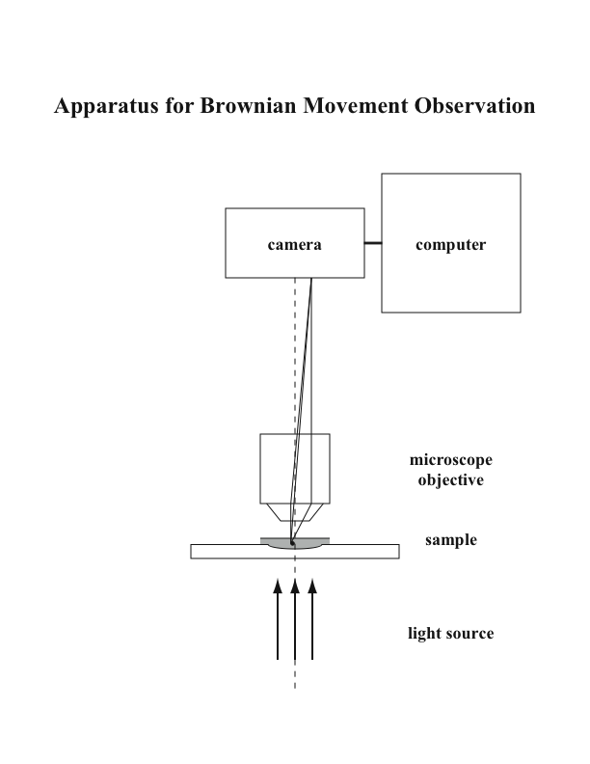
Figure 1.

